Schema accountingDataSchema_1.1.0.json

Version: | draft-2020-12
Definitions: | AccountingDataDelivery  AccountingDeliveryDetails  AccountingRecord  Transaction  Subject  AccountedAmount  AccountingType  ClassCode  PassengerType  PaymentType  SalesChannel  SalesType  SettlementValueIndicator  TransactionStandard  TransactionType

Document schema
accountingDataSchema_1.1.0.jsondiagram | 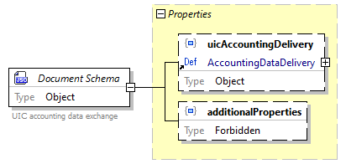
location | https://github.com/UnionInternationalCheminsdeFer/UIC-Accounting-File-Viewer/blob/main/UIC%20Accounting%20File/accounting%20schema/accountingDataSchema_1.1.0.json
schema details
  Id | accountingDataDelivery_1.1.0.json
  Description | UIC accounting data exchange
type | Object
properties
  Name | Occurrence
  uicAccountingDelivery | Optional
  additionalProperties | Optional
source code | {  "$schema": "https://json-schema.org/draft/2020-12/schema",  "$id": "accountingDataDelivery_1.1.0.json",  "description": "UIC accounting data exchange",  "type": "object",  "properties": {  "uicAccountingDelivery": {  "$ref": "#/definitions/AccountingDataDelivery"  },  "additionalProperties": false  },  "additionalProperties": false,  "version": "1.1.0"  }

Property
Untitled5.json /
uicAccountingDeliverydiagram | 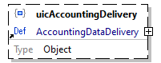
property details
  Occurrence | Optional
reference | AccountingDataDelivery
source code | "uicAccountingDelivery": {  "$ref": "#/definitions/AccountingDataDelivery"  }

Property
Untitled5.json /
additionalPropertiesdiagram | 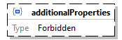
property details
  Occurrence | Optional
type | Forbidden
source code | "additionalProperties": false

Schema definition
AccountingDataDeliverydiagram | 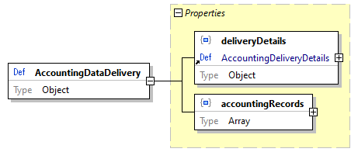
location | D:\Users\BKU\ClemensGantert\OneDrive - Deutsche Bahn\Anlagen\UIC\Standards\918-4\IRS 90918-4 v 3.0\90918-4 technical specs v3.0\90918-4_json_Schema_3_0_0\Untitled5.json
type | Object
properties
  Name | Occurrence
  deliveryDetails | Required
  accountingRecords | Required
used by | Untitled5.json /  uicAccountingDelivery
source code | "AccountingDataDelivery": {  "type": "object",  "properties": {  "deliveryDetails": {  "$ref": "#/definitions/AccountingDeliveryDetails"  },  "accountingRecords": {  "type": "array",  "items": {  "$ref": "#/definitions/AccountingRecord"  }  }  },  "required": [  "deliveryDetails",  "accountingRecords"  ],  "additionalProperties": false  }

Property
AccountingDataDelivery /
deliveryDetailsdiagram | 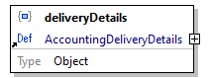
property details
  Occurrence | Required
reference | AccountingDeliveryDetails
source code | "deliveryDetails": {  "$ref": "#/definitions/AccountingDeliveryDetails"  }

Property
AccountingDataDelivery /
accountingRecordsdiagram | 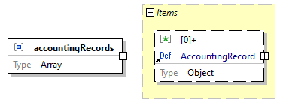
property details
  Occurrence | Required
type | Array
array items
  [0]+ | AccountingRecord
source code | "accountingRecords": {  "type": "array",  "items": {  "$ref": "#/definitions/AccountingRecord"  }  }

Schema definition
AccountingDeliveryDetailsdiagram | 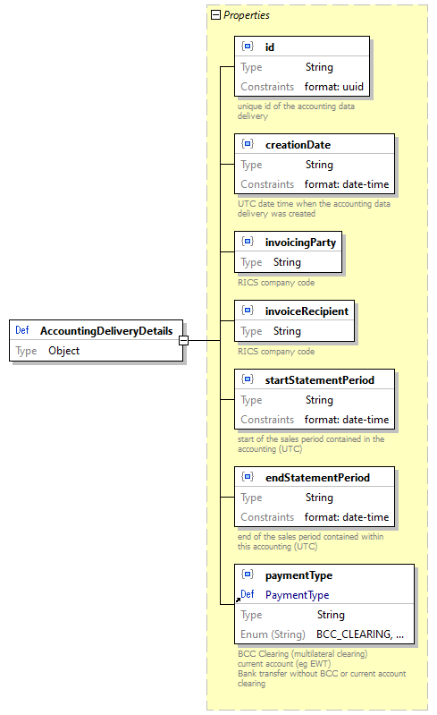
location | D:\Users\BKU\ClemensGantert\OneDrive - Deutsche Bahn\Anlagen\UIC\Standards\918-4\IRS 90918-4 v 3.0\90918-4 technical specs v3.0\90918-4_json_Schema_3_0_0\Untitled5.json
type | Object
properties
  Name | Occurrence
  id | Required
  creationDate | Required
  invoicingParty | Required
  invoiceRecipient | Required
  startStatementPeriod | Required
  endStatementPeriod | Required
  paymentType | Required
used by | AccountingDataDelivery /  deliveryDetails
source code | "AccountingDeliveryDetails": {  "type": "object",  "properties": {  "id": {  "description": "unique id of the accounting data delivery",  "type": "string",  "format": "uuid"  },  "creationDate": {  "description": "UTC date time when the accounting data delivery was created",  "type": "string",  "format": "date-time"  },  "invoicingParty": {  "description": "RICS company code",  "type": "string"  },  "invoiceRecipient": {  "description": "RICS company code",  "type": "string"  },  "startStatementPeriod": {  "description": "start of the sales period contained in the accounting (UTC)",  "type": "string",  "format": "date-time"  },  "endStatementPeriod": {  "description": "end of the sales period contained within this accounting (UTC)",  "type": "string",  "format": "date-time"  },  "paymentType": {  "$ref": "#/definitions/PaymentType"  }  },  "required": [  "id",  "creationDate",  "invoicingParty",  "invoiceRecipient",  "startStatementPeriod",  "endStatementPeriod",  "paymentType"  ],  "additionalProperties": false  }

Property
AccountingDeliveryDetails /
iddiagram | 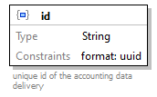
property details
  Occurrence | Required
schema details
  Description | unique id of the accounting data delivery
type | String
string constraints
  Format | uuid
source code | "id": {  "description": "unique id of the accounting data delivery",  "type": "string",  "format": "uuid"  }

Property
AccountingDeliveryDetails /
creationDatediagram | 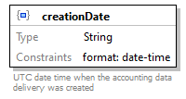
property details
  Occurrence | Required
schema details
  Description | UTC date time when the accounting data delivery was created
type | String
string constraints
  Format | date-time
source code | "creationDate": {  "description": "UTC date time when the accounting data delivery was created",  "type": "string",  "format": "date-time"  }

Property
AccountingDeliveryDetails /
invoicingPartydiagram | 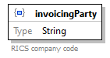
property details
  Occurrence | Required
schema details
  Description | RICS company code
type | String
source code | "invoicingParty": {  "description": "RICS company code",  "type": "string"  }

Property
AccountingDeliveryDetails /
invoiceRecipientdiagram | 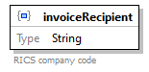
property details
  Occurrence | Required
schema details
  Description | RICS company code
type | String
source code | "invoiceRecipient": {  "description": "RICS company code",  "type": "string"  }

Property
AccountingDeliveryDetails /
startStatementPerioddiagram | 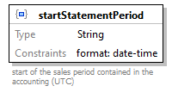
property details
  Occurrence | Required
schema details
  Description | start of the sales period contained in the accounting (UTC)
type | String
string constraints
  Format | date-time
source code | "startStatementPeriod": {  "description": "start of the sales period contained in the accounting (UTC)",  "type": "string",  "format": "date-time"  }

Property
AccountingDeliveryDetails /
endStatementPerioddiagram | 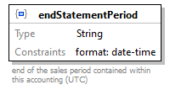
property details
  Occurrence | Required
schema details
  Description | end of the sales period contained within this accounting (UTC)
type | String
string constraints
  Format | date-time
source code | "endStatementPeriod": {  "description": "end of the sales period contained within this accounting (UTC)",  "type": "string",  "format": "date-time"  }

Property
AccountingDeliveryDetails /
paymentTypediagram | 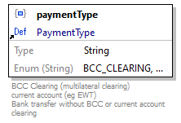
property details
  Occurrence | Required
reference | PaymentType
source code | "paymentType": {  "$ref": "#/definitions/PaymentType"  }

Schema definition
AccountingRecorddiagram | 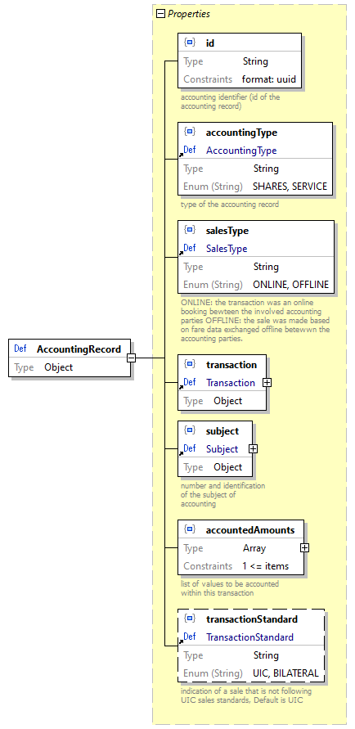
location | D:\Users\BKU\ClemensGantert\OneDrive - Deutsche Bahn\Anlagen\UIC\Standards\918-4\IRS 90918-4 v 3.0\90918-4 technical specs v3.0\90918-4_json_Schema_3_0_0\Untitled5.json
type | Object
properties
  Name | Occurrence
  id | Required
  accountingType | Required
  salesType | Required
  transaction | Required
  subject | Required
  accountedAmounts | Required
  transactionStandard | Optional
used by | AccountingDataDelivery /  accountingRecords
source code | "AccountingRecord": {  "type": "object",  "properties": {  "id": {  "description": "accounting identifier (id of the accounting record) ",  "type": "string",  "format": "uuid"  },  "accountingType": {  "$ref": "#/definitions/AccountingType"  },  "salesType": {  "$ref": "#/definitions/SalesType"  },  "transaction": {  "$ref": "#/definitions/Transaction"  },  "subject": {  "$ref": "#/definitions/Subject"  },  "accountedAmounts": {  "description": "list of values to be accounted within this transaction",  "type": "array",  "minItems": 1,  "items": {  "$ref": "#/definitions/AccountedAmount"  }  },  "transactionStandard": {  "$ref": "#/definitions/TransactionStandard"  }  },  "required": [  "id",  "accountingType",  "salesType",  "transaction",  "subject",  "accountedAmounts"  ],  "additionalProperties": false  }

Property
AccountingRecord /
iddiagram | 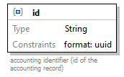
property details
  Occurrence | Required
schema details
  Description | accounting identifier (id of the accounting record)
type | String
string constraints
  Format | uuid
source code | "id": {  "description": "accounting identifier (id of the accounting record) ",  "type": "string",  "format": "uuid"  }

Property
AccountingRecord /
accountingTypediagram | 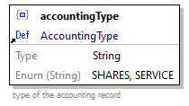
property details
  Occurrence | Required
reference | AccountingType
source code | "accountingType": {  "$ref": "#/definitions/AccountingType"  }

Property
AccountingRecord /
salesTypediagram | 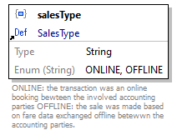
property details
  Occurrence | Required
reference | SalesType
source code | "salesType": {  "$ref": "#/definitions/SalesType"  }

Property
AccountingRecord /
transactiondiagram | 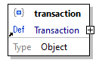
property details
  Occurrence | Required
reference | Transaction
source code | "transaction": {  "$ref": "#/definitions/Transaction"  }

Property
AccountingRecord /
subjectdiagram | 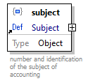
property details
  Occurrence | Required
reference | Subject
source code | "subject": {  "$ref": "#/definitions/Subject"  }

Property
AccountingRecord /
accountedAmountsdiagram | 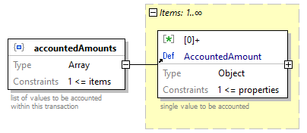
property details
  Occurrence | Required
schema details
  Description | list of values to be accounted within this transaction
type | Array
array constraints
  Min Items | 1
array items
  [0]+ | AccountedAmount
source code | "accountedAmounts": {  "description": "list of values to be accounted within this transaction",  "type": "array",  "minItems": 1,  "items": {  "$ref": "#/definitions/AccountedAmount"  }  }

Property
AccountingRecord /
transactionStandarddiagram | 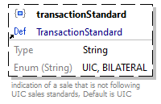
property details
  Occurrence | Optional
reference | TransactionStandard
source code | "transactionStandard": {  "$ref": "#/definitions/TransactionStandard"  }

Schema definition
Transactiondiagram | 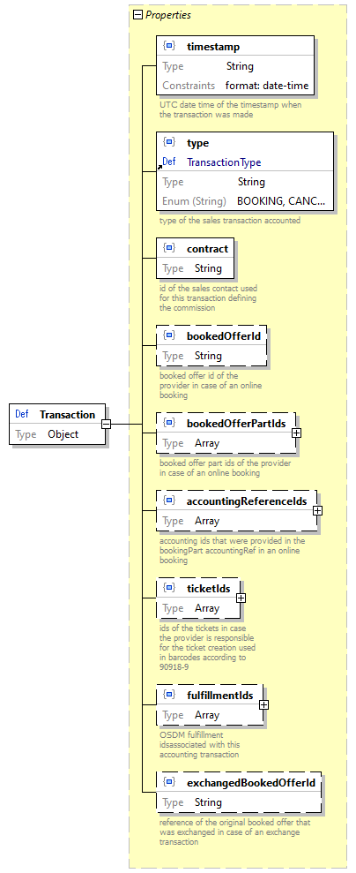
location | D:\Users\BKU\ClemensGantert\OneDrive - Deutsche Bahn\Anlagen\UIC\Standards\918-4\IRS 90918-4 v 3.0\90918-4 technical specs v3.0\90918-4_json_Schema_3_0_0\Untitled5.json
type | Object
properties
  Name | Occurrence
  timestamp | Required
  type | Required
  contract | Required
  bookedOfferId | Optional
  bookedOfferPartIds | Optional
  accountingReferenceIds | Optional
  ticketIds | Optional
  fulfillmentIds | Optional
  exchangedBookedOfferId | Optional
used by | AccountingRecord /  transaction
source code | "Transaction": {  "type": "object",  "properties": {  "timestamp": {  "description": "UTC date time of the timestamp when the transaction was made",  "type": "string",  "format": "date-time"  },  "type": {  "$ref": "#/definitions/TransactionType"  },  "contract": {  "description": "id of the sales contact used for this transaction defining the commission",  "type": "string"  },  "bookedOfferId": {  "description": "booked offer id of the provider in case of an online booking",  "type": "string"  },  "bookedOfferPartIds": {  "description": "booked offer part ids of the provider in case of an online booking",  "type": "array",  "items": {  "type": "string"  }  },  "accountingReferenceIds": {  "description": "accounting ids that were provided in the bookingPart accountingRef in an online booking",  "type": "array",  "items": {  "type": "string"  }  },  "ticketIds": {  "description": "ids of the tickets in case the provider is responsible for the ticket creation used in barcodes according to 90918-9",  "type": "array",  "items": {  "type": "string"  }  },  "fulfillmentIds": {  "description": "OSDM fulfillment idsassociated with this accounting transaction",  "type": "array",  "items": {  "type": "string"  }  },  "exchangedBookedOfferId": {  "description": "reference of the original booked offer that was exchanged in case of an exchange transaction",  "type": "string"  }  },  "required": [  "timestamp",  "type",  "contract"  ],  "additionalProperties": false  }

Property
Transaction /
timestampdiagram | 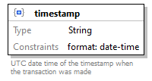
property details
  Occurrence | Required
schema details
  Description | UTC date time of the timestamp when the transaction was made
type | String
string constraints
  Format | date-time
source code | "timestamp": {  "description": "UTC date time of the timestamp when the transaction was made",  "type": "string",  "format": "date-time"  }

Property
Transaction /
typediagram | 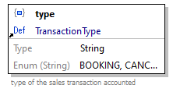
property details
  Occurrence | Required
reference | TransactionType
source code | "type": {  "$ref": "#/definitions/TransactionType"  }

Property
Transaction /
contractdiagram | 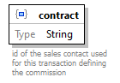
property details
  Occurrence | Required
schema details
  Description | id of the sales contact used for this transaction defining the commission
type | String
source code | "contract": {  "description": "id of the sales contact used for this transaction defining the commission",  "type": "string"  }

Property
Transaction /
bookedOfferIddiagram | 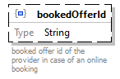
property details
  Occurrence | Optional
schema details
  Description | booked offer id of the provider in case of an online booking
type | String
source code | "bookedOfferId": {  "description": "booked offer id of the provider in case of an online booking",  "type": "string"  }

Property
Transaction /
bookedOfferPartIdsdiagram | 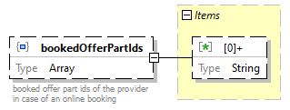
property details
  Occurrence | Optional
schema details
  Description | booked offer part ids of the provider in case of an online booking
type | Array
array items
  [0]+ | Schema
source code | "bookedOfferPartIds": {  "description": "booked offer part ids of the provider in case of an online booking",  "type": "array",  "items": {  "type": "string"  }  }

Array item wildcard
Transaction /
bookedOfferPartIds > array items [0]+ /
Schemadiagram | 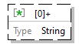
type | String
source code | "items": {  "type": "string"  }

Property
Transaction /
accountingReferenceIdsdiagram | 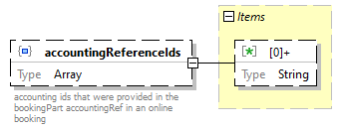
property details
  Occurrence | Optional
schema details
  Description | accounting ids that were provided in the bookingPart accountingRef in an online booking
type | Array
array items
  [0]+ | Schema
source code | "accountingReferenceIds": {  "description": "accounting ids that were provided in the bookingPart accountingRef in an online booking",  "type": "array",  "items": {  "type": "string"  }  }

Array item wildcard
Transaction /
accountingReferenceIds > array items [0]+ /
Schemadiagram
type | String
source code | "items": {  "type": "string"  }

Property
Transaction /
ticketIdsdiagram | 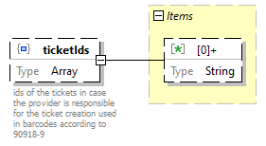
property details
  Occurrence | Optional
schema details
  Description | ids of the tickets in case the provider is responsible for the ticket creation used in barcodes according to 90918-9
type | Array
array items
  [0]+ | Schema
source code | "ticketIds": {  "description": "ids of the tickets in case the provider is responsible for the ticket creation used in barcodes according to 90918-9",  "type": "array",  "items": {  "type": "string"  }  }

Array item wildcard
Transaction /
ticketIds > array items [0]+ /
Schemadiagram
type | String
source code | "items": {  "type": "string"  }

Property
Transaction /
fulfillmentIdsdiagram | 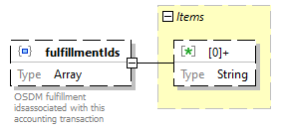
property details
  Occurrence | Optional
schema details
  Description | OSDM fulfillment idsassociated with this accounting transaction
type | Array
array items
  [0]+ | Schema
source code | "fulfillmentIds": {  "description": "OSDM fulfillment idsassociated with this accounting transaction",  "type": "array",  "items": {  "type": "string"  }  }

Array item wildcard
Transaction /
fulfillmentIds > array items [0]+ /
Schemadiagram
type | String
source code | "items": {  "type": "string"  }

Property
Transaction /
exchangedBookedOfferIddiagram | 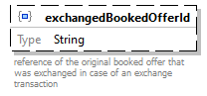
property details
  Occurrence | Optional
schema details
  Description | reference of the original booked offer that was exchanged in case of an exchange transaction
type | String
source code | "exchangedBookedOfferId": {  "description": "reference of the original booked offer that was exchanged in case of an exchange transaction",  "type": "string"  }

Schema definition
Subjectdiagram | 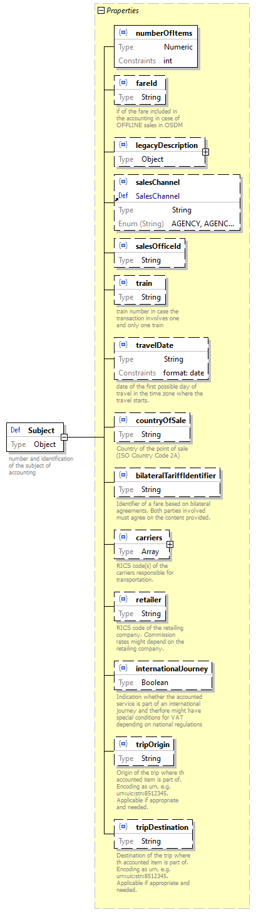
location | D:\Users\BKU\ClemensGantert\OneDrive - Deutsche Bahn\Anlagen\UIC\Standards\918-4\IRS 90918-4 v 3.0\90918-4 technical specs v3.0\90918-4_json_Schema_3_0_0\Untitled5.json
schema details
  Description | number and identification of the subject of accounting
type | Object
properties
  Name | Occurrence
  numberOfItems | Required
  fareId | Optional
  legacyDescription | Optional
  salesChannel | Optional
  salesOfficeId | Optional
  train | Optional
  travelDate | Optional
  countryOfSale | Optional
  bilateralTariffIdentifier | Optional
  carriers | Optional
  retailer | Optional
  internationalJourney | Optional
  tripOrigin | Optional
  tripDestination | Optional
used by | AccountingRecord /  subject
source code | "Subject": {  "description": "number and identification of the subject of accounting ",  "type": "object",  "properties": {  "numberOfItems": {  "type": "integer"  },  "fareId": {  "description": "if of the fare included in the accounting in case of OFFLINE sales in OSDM",  "type": "string"  },  "legacyDescription": {  "type": "object",  "properties": {  "series": {  "type": "integer",  "minimum": 0,  "maximum": 99999  },  "tariff": {  "type": "integer",  "minimum": 0,  "maximum": 99999  },  "classCode": {  "$ref": "#/definitions/ClassCode"  },  "passengerType": {  "$ref": "#/definitions/PassengerType"  },  "dialogNumber": {  "description": "identification of the communication that caused the transaction e.g. the dialog number in the booking transaction according to IRS 90918-1. ",  "type": "string"  }  },  "required": [  "series",  "tariff",  "classCode",  "passengerType"  ],  "additionalProperties": false  },  "salesChannel": {  "$ref": "#/definitions/SalesChannel"  },  "salesOfficeId": {  "type": "string"  },  "train": {  "description": "train number in case the transaction involves one and only one train",  "type": "string"  },  "travelDate": {  "description": "date of the first possible day of travel in the time zone where the travel starts.",  "type": "string",  "format": "date"  },  "countryOfSale": {  "description": "Country of the point of sale (ISO Country Code 2A)",  "type": "string"  },  "bilateralTariffIdentifier": {  "description": "Identifier of a fare based on bilateral agreements. Both parties involved must agree on the content provided.",  "type": "string"  },  "carriers": {  "description": "RICS code(s) of the carriers responsible for transportation. ",  "type": "array",  "items": {  "type": "string"  }  },  "retailer": {  "description": "RICS code of the retailing company. Commission rates might depend on the retailing company.",  "type": "string"  },  "internationalJourney": {  "description": "Indication whether the accounted service is part of an international journey and therfore might have special conditions for VAT depending on national regulations",  "type": "boolean"  },  "tripOrigin": {  "description": "Origin of the trip where th accounted item is part of. Encoding as urn, e.g. urn:uic:stn:8512345. Applicable if appropriate and needed.",  "type": "string"  },  "tripDestination": {  "description": "Destination of the trip where th accounted item is part of. Encoding as urn, e.g. urn:uic:stn:8512345. Applicable if appropriate and needed.",  "type": "string"  }  },  "required": [  "numberOfItems"  ],  "additionalProperties": false  }

Property
Subject /
numberOfItemsdiagram | 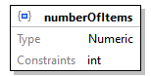
property details
  Occurrence | Required
type | Numeric
numeric constraints
  Mode | Integer
source code | "numberOfItems": {  "type": "integer"  }

Property
Subject /
fareIddiagram | 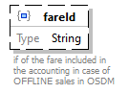
property details
  Occurrence | Optional
schema details
  Description | if of the fare included in the accounting in case of OFFLINE sales in OSDM
type | String
source code | "fareId": {  "description": "if of the fare included in the accounting in case of OFFLINE sales in OSDM",  "type": "string"  }

Property
Subject /
legacyDescriptiondiagram | 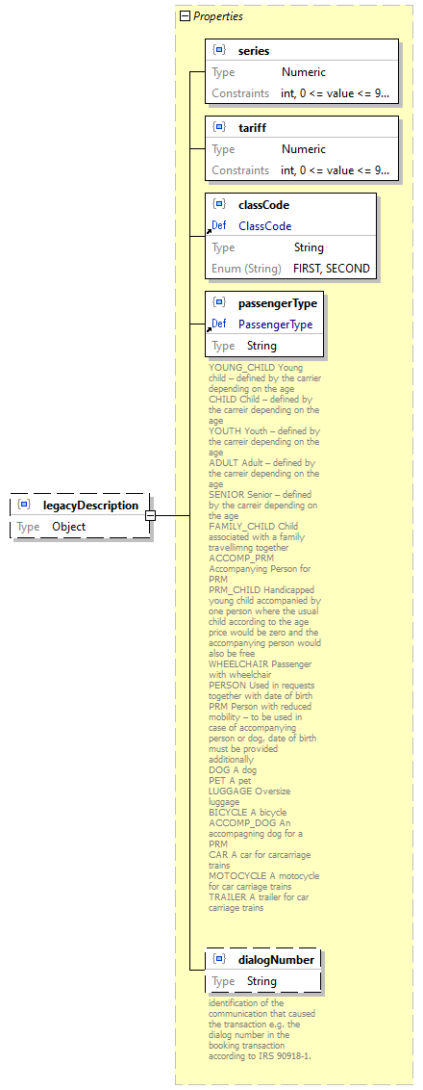
property details
  Occurrence | Optional
type | Object
properties
  Name | Occurrence
  series | Required
  tariff | Required
  classCode | Required
  passengerType | Required
  dialogNumber | Optional
source code | "legacyDescription": {  "type": "object",  "properties": {  "series": {  "type": "integer",  "minimum": 0,  "maximum": 99999  },  "tariff": {  "type": "integer",  "minimum": 0,  "maximum": 99999  },  "classCode": {  "$ref": "#/definitions/ClassCode"  },  "passengerType": {  "$ref": "#/definitions/PassengerType"  },  "dialogNumber": {  "description": "identification of the communication that caused the transaction e.g. the dialog number in the booking transaction according to IRS 90918-1. ",  "type": "string"  }  },  "required": [  "series",  "tariff",  "classCode",  "passengerType"  ],  "additionalProperties": false  }

Property
Subject /
legacyDescription /
seriesdiagram | 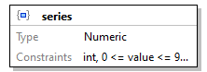
property details
  Occurrence | Required
type | Numeric
numeric constraints
  Mode | Integer
  Minimum | 0
  Maximum | 99999
source code | "series": {  "type": "integer",  "minimum": 0,  "maximum": 99999  }

Property
Subject /
legacyDescription /
tariffdiagram | 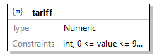
property details
  Occurrence | Required
type | Numeric
numeric constraints
  Mode | Integer
  Minimum | 0
  Maximum | 99999
source code | "tariff": {  "type": "integer",  "minimum": 0,  "maximum": 99999  }

Property
Subject /
legacyDescription /
classCodediagram | 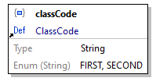
property details
  Occurrence | Required
reference | ClassCode
source code | "classCode": {  "$ref": "#/definitions/ClassCode"  }

Property
Subject /
legacyDescription /
passengerTypediagram | 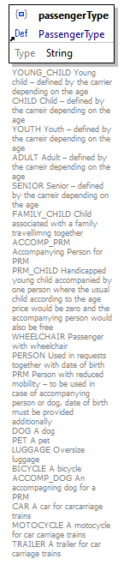
property details
  Occurrence | Required
reference | PassengerType
source code | "passengerType": {  "$ref": "#/definitions/PassengerType"  }

Property
Subject /
legacyDescription /
dialogNumberdiagram | 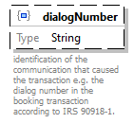
property details
  Occurrence | Optional
schema details
  Description | identification of the communication that caused the transaction e.g. the dialog number in the booking transaction according to IRS 90918-1.
type | String
source code | "dialogNumber": {  "description": "identification of the communication that caused the transaction e.g. the dialog number in the booking transaction according to IRS 90918-1. ",  "type": "string"  }

Property
Subject /
salesChanneldiagram | 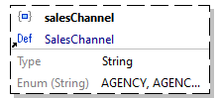
property details
  Occurrence | Optional
reference | SalesChannel
source code | "salesChannel": {  "$ref": "#/definitions/SalesChannel"  }

Property
Subject /
salesOfficeIddiagram | 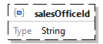
property details
  Occurrence | Optional
type | String
source code | "salesOfficeId": {  "type": "string"  }

Property
Subject /
traindiagram | 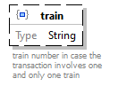
property details
  Occurrence | Optional
schema details
  Description | train number in case the transaction involves one and only one train
type | String
source code | "train": {  "description": "train number in case the transaction involves one and only one train",  "type": "string"  }

Property
Subject /
travelDatediagram | 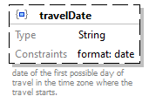
property details
  Occurrence | Optional
schema details
  Description | date of the first possible day of travel in the time zone where the travel starts.
type | String
string constraints
  Format | date
source code | "travelDate": {  "description": "date of the first possible day of travel in the time zone where the travel starts.",  "type": "string",  "format": "date"  }

Property
Subject /
countryOfSalediagram | 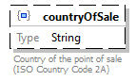
property details
  Occurrence | Optional
schema details
  Description | Country of the point of sale (ISO Country Code 2A)
type | String
source code | "countryOfSale": {  "description": "Country of the point of sale (ISO Country Code 2A)",  "type": "string"  }

Property
Subject /
bilateralTariffIdentifierdiagram | 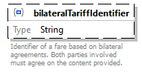
property details
  Occurrence | Optional
schema details
  Description | Identifier of a fare based on bilateral agreements. Both parties involved must agree on the content provided.
type | String
source code | "bilateralTariffIdentifier": {  "description": "Identifier of a fare based on bilateral agreements. Both parties involved must agree on the content provided.",  "type": "string"  }

Property
Subject /
carriersdiagram | 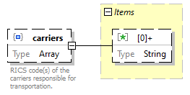
property details
  Occurrence | Optional
schema details
  Description | RICS code(s) of the carriers responsible for transportation.
type | Array
array items
  [0]+ | Schema
source code | "carriers": {  "description": "RICS code(s) of the carriers responsible for transportation. ",  "type": "array",  "items": {  "type": "string"  }  }

Array item wildcard
Subject /
carriers > array items [0]+ /
Schemadiagram
type | String
source code | "items": {  "type": "string"  }

Property
Subject /
retailerdiagram | 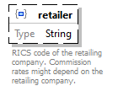
property details
  Occurrence | Optional
schema details
  Description | RICS code of the retailing company. Commission rates might depend on the retailing company.
type | String
source code | "retailer": {  "description": "RICS code of the retailing company. Commission rates might depend on the retailing company.",  "type": "string"  }

Property
Subject /
internationalJourneydiagram | 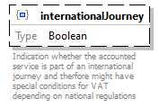
property details
  Occurrence | Optional
schema details
  Description | Indication whether the accounted service is part of an international journey and therfore might have special conditions for VAT depending on national regulations
type | Boolean
source code | "internationalJourney": {  "description": "Indication whether the accounted service is part of an international journey and therfore might have special conditions for VAT depending on national regulations",  "type": "boolean"  }

Property
Subject /
tripOrigindiagram | 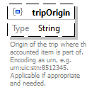
property details
  Occurrence | Optional
schema details
  Description | Origin of the trip where th accounted item is part of. Encoding as urn, e.g. urn:uic:stn:8512345. Applicable if appropriate and needed.
type | String
source code | "tripOrigin": {  "description": "Origin of the trip where th accounted item is part of. Encoding as urn, e.g. urn:uic:stn:8512345. Applicable if appropriate and needed.",  "type": "string"  }

Property
Subject /
tripDestinationdiagram | 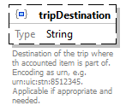
property details
  Occurrence | Optional
schema details
  Description | Destination of the trip where th accounted item is part of. Encoding as urn, e.g. urn:uic:stn:8512345. Applicable if appropriate and needed.
type | String
source code | "tripDestination": {  "description": "Destination of the trip where th accounted item is part of. Encoding as urn, e.g. urn:uic:stn:8512345. Applicable if appropriate and needed.",  "type": "string"  }

Schema definition
AccountedAmountdiagram | 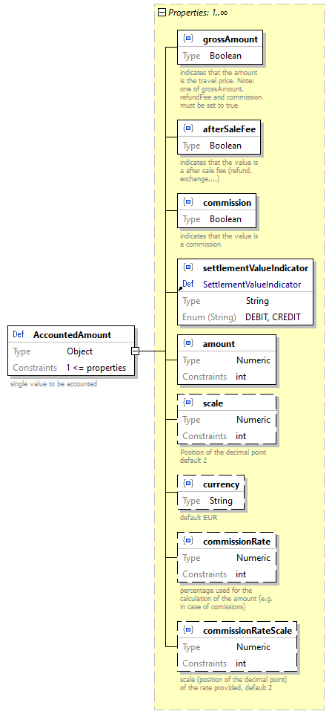
location | D:\Users\BKU\ClemensGantert\OneDrive - Deutsche Bahn\Anlagen\UIC\Standards\918-4\IRS 90918-4 v 3.0\90918-4 technical specs v3.0\90918-4_json_Schema_3_0_0\Untitled5.json
schema details
  Description | single value to be accounted
type | Object
object constraints
  Min Props | 1
properties
  Name | Occurrence
  grossAmount | Required
  afterSaleFee | Required
  commission | Required
  settlementValueIndicator | Required
  amount | Required
  scale | Optional
  currency | Optional
  commissionRate | Optional
  commissionRateScale | Optional
used by | AccountingRecord /  accountedAmounts
source code | "AccountedAmount": {  "description": "single value to be accounted",  "type": "object",  "minProperties": 1,  "properties": {  "grossAmount": {  "description": "indicates that the amount is the travel price. Note: one of grossAmount, refundFee and commission must be set to true",  "type": "boolean"  },  "afterSaleFee": {  "description": "indicates that the value is a after sale fee (refund, exchange,...)",  "type": "boolean"  },  "commission": {  "description": "indicates that the value is a commission",  "type": "boolean"  },  "settlementValueIndicator": {  "$ref": "#/definitions/SettlementValueIndicator"  },  "amount": {  "type": "integer",  "format": "int32"  },  "scale": {  "description": "Position of the decimal point default 2",  "type": "integer",  "default": 2  },  "currency": {  "description": "default EUR",  "type": "string",  "default": "EUR"  },  "commissionRate": {  "description": "percentage used for the calculation of the amount (e.g. in case of comissions)",  "type": "integer"  },  "commissionRateScale": {  "description": "scale (position of the decimal point) of the rate provided, default 2",  "type": "integer",  "default": 2  }  },  "required": [  "grossAmount",  "afterSaleFee",  "commission",  "settlementValueIndicator",  "amount"  ],  "additionalProperties": false  }

Property
AccountedAmount /
grossAmountdiagram | 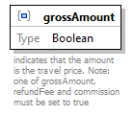
property details
  Occurrence | Required
schema details
  Description | indicates that the amount is the travel price. Note: one of grossAmount, refundFee and commission must be set to true
type | Boolean
source code | "grossAmount": {  "description": "indicates that the amount is the travel price. Note: one of grossAmount, refundFee and commission must be set to true",  "type": "boolean"  }

Property
AccountedAmount /
afterSaleFeediagram | 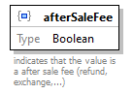
property details
  Occurrence | Required
schema details
  Description | indicates that the value is a after sale fee (refund, exchange,...)
type | Boolean
source code | "afterSaleFee": {  "description": "indicates that the value is a after sale fee (refund, exchange,...)",  "type": "boolean"  }

Property
AccountedAmount /
commissiondiagram | 
property details
  Occurrence | Required
schema details
  Description | indicates that the value is a commission
type | Boolean
source code | "commission": {  "description": "indicates that the value is a commission",  "type": "boolean"  }

Property
AccountedAmount /
settlementValueIndicatordiagram | 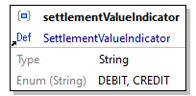
property details
  Occurrence | Required
reference | SettlementValueIndicator
source code | "settlementValueIndicator": {  "$ref": "#/definitions/SettlementValueIndicator"  }

Property
AccountedAmount /
amountdiagram | 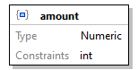
property details
  Occurrence | Required
type | Numeric
string constraints
  Format | int32
numeric constraints
  Mode | Integer
source code | "amount": {  "type": "integer",  "format": "int32"  }

Property
AccountedAmount /
scalediagram | 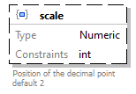
property details
  Occurrence | Optional
schema details
  Description | Position of the decimal point default 2
  Default | 2
type | Numeric
numeric constraints
  Mode | Integer
source code | "scale": {  "description": "Position of the decimal point default 2",  "type": "integer",  "default": 2  }

Property
AccountedAmount /
currencydiagram | 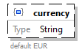
property details
  Occurrence | Optional
schema details
  Description | default EUR
  Default | "EUR"
type | String
source code | "currency": {  "description": "default EUR",  "type": "string",  "default": "EUR"  }

Property
AccountedAmount /
commissionRatediagram | 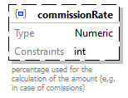
property details
  Occurrence | Optional
schema details
  Description | percentage used for the calculation of the amount (e.g. in case of comissions)
type | Numeric
numeric constraints
  Mode | Integer
source code | "commissionRate": {  "description": "percentage used for the calculation of the amount (e.g. in case of comissions)",  "type": "integer"  }

Property
AccountedAmount /
commissionRateScalediagram | 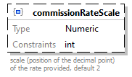
property details
  Occurrence | Optional
schema details
  Description | scale (position of the decimal point) of the rate provided, default 2
  Default | 2
type | Numeric
numeric constraints
  Mode | Integer
source code | "commissionRateScale": {  "description": "scale (position of the decimal point) of the rate provided, default 2",  "type": "integer",  "default": 2  }

Schema definition
AccountingTypediagram | 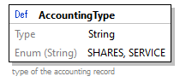
location | D:\Users\BKU\ClemensGantert\OneDrive - Deutsche Bahn\Anlagen\UIC\Standards\918-4\IRS 90918-4 v 3.0\90918-4 technical specs v3.0\90918-4_json_Schema_3_0_0\Untitled5.json
schema details
  Description | type of the accounting record
type | String
enumerations
  Type | Value
  string | SHARES
  string | SERVICE
used by | AccountingRecord /  accountingType
source code | "AccountingType": {  "description": "type of the accounting record",  "type": "string",  "enum": [  "SHARES",  "SERVICE"  ]  }

Schema definition
ClassCodediagram | 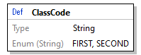
location | D:\Users\BKU\ClemensGantert\OneDrive - Deutsche Bahn\Anlagen\UIC\Standards\918-4\IRS 90918-4 v 3.0\90918-4 technical specs v3.0\90918-4_json_Schema_3_0_0\Untitled5.json
type | String
enumerations
  Type | Value
  string | FIRST
  string | SECOND
used by | Subject /  legacyDescription /  classCode
source code | "ClassCode": {  "type": "string",  "enum": [  "FIRST",  "SECOND"  ]  }

Schema definition
PassengerTypediagram | 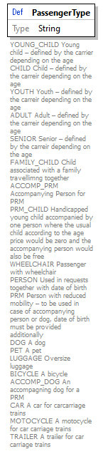
location | D:\Users\BKU\ClemensGantert\OneDrive - Deutsche Bahn\Anlagen\UIC\Standards\918-4\IRS 90918-4 v 3.0\90918-4 technical specs v3.0\90918-4_json_Schema_3_0_0\Untitled5.json
schema details
  Description | YOUNG_CHILD Young child – defined by the carrier depending on the age  CHILD Child – defined by the carreir depending on the age  YOUTH Youth – defined by the carreir depending on the age  ADULT Adult – defined by the carreir depending on the age  SENIOR Senior – defined by the carreir depending on the age  FAMILY_CHILD Child associated with a family travellimng together  ACCOMP_PRM Accompanying Person for PRM  PRM_CHILD Handicapped young child accompanied by one person where the usual child according to the age price would be zero and the accompanying person would also be free  WHEELCHAIR Passenger with wheelchair  PERSON Used in requests together with date of birth  PRM Person with reduced mobility – to be used in case of accompanying person or dog, date of birth must be provided additionally  DOG A dog  PET A pet  LUGGAGE Oversize luggage  BICYCLE A bicycle  ACCOMP_DOG An accompagning dog for a PRM  CAR A car for carcarriage trains  MOTOCYCLE A motocycle for car carriage trains  TRAILER A trailer for car carriage trains
type | String
used by | Subject /  legacyDescription /  passengerType
source code | "PassengerType": {  "description": "YOUNG_CHILD Young child – defined by the carrier depending on the age \r\nCHILD Child – defined by the carreir depending on the age \r\nYOUTH Youth – defined by the carreir depending on the age \r\nADULT Adult – defined by the carreir depending on the age \r\nSENIOR Senior – defined by the carreir depending on the age \r\nFAMILY_CHILD Child associated with a family travellimng together \r\nACCOMP_PRM Accompanying Person for PRM \r\nPRM_CHILD Handicapped young child accompanied by one person where the usual child according to the age price would be zero and the accompanying person would also be free \r\nWHEELCHAIR Passenger with wheelchair \r\nPERSON Used in requests together with date of birth \r\nPRM Person with reduced mobility – to be used in case of accompanying person or dog, date of birth must be provided additionally \r\nDOG A dog \r\nPET A pet \r\nLUGGAGE Oversize luggage \r\nBICYCLE A bicycle \r\nACCOMP_DOG An accompagning dog for a PRM \r\nCAR A car for carcarriage trains \r\nMOTOCYCLE A motocycle for car carriage trains \r\nTRAILER A trailer for car carriage trains",  "type": "string",  "x-extensible-enum": [  "YOUNG_CHILD",  "CHILD",  "YOUTH",  "ADULT",  "SENIOR",  "FAMILY_CHILD",  "ACCOMP_PRM",  "PRM_CHILD",  "WHEELCHAIR",  "PERSON",  "PRM",  "DOG",  "PET",  "BICYCLE",  "ACCOMP_DOG",  "PRM",  "CAR",  "MOTOCYCLE",  "TRAILER"  ]  }

Schema definition
PaymentTypediagram | 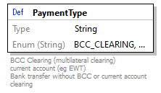
location | D:\Users\BKU\ClemensGantert\OneDrive - Deutsche Bahn\Anlagen\UIC\Standards\918-4\IRS 90918-4 v 3.0\90918-4 technical specs v3.0\90918-4_json_Schema_3_0_0\Untitled5.json
schema details
  Description | BCC Clearing (multilateral clearing)  current account (eg EWT)  Bank transfer without BCC or current account clearing
type | String
enumerations
  Type | Value
  string | BCC_CLEARING
  string | CURRENT_ACCOUNT
  string | BANK_TRANSFER
  string | CURRENT_ACCOUNT_CLEARING
used by | AccountingDeliveryDetails /  paymentType
source code | "PaymentType": {  "description": "BCC Clearing (multilateral clearing) \r\ncurrent account (eg EWT)\r\nBank transfer without BCC or current account clearing",  "type": "string",  "enum": [  "BCC_CLEARING",  "CURRENT_ACCOUNT",  "BANK_TRANSFER",  "CURRENT_ACCOUNT_CLEARING"  ]  }

Schema definition
SalesChanneldiagram | 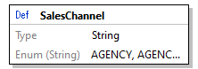
location | D:\Users\BKU\ClemensGantert\OneDrive - Deutsche Bahn\Anlagen\UIC\Standards\918-4\IRS 90918-4 v 3.0\90918-4 technical specs v3.0\90918-4_json_Schema_3_0_0\Untitled5.json
type | String
enumerations
  Type | Value
  string | AGENCY
  string | AGENCY_WEB
  string | MOBILE
  string | RAIL_OFFICE
  string | VENDING_MACHINE
  string | WEB
  string | WEB_MOBILE
  string | ON_BOARD
used by | Subject /  salesChannel
source code | "SalesChannel": {  "type": "string",  "enum": [  "AGENCY",  "AGENCY_WEB",  "MOBILE",  "RAIL_OFFICE",  "VENDING_MACHINE",  "WEB",  "WEB_MOBILE",  "ON_BOARD"  ]  }

Schema definition
SalesTypediagram | 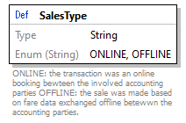
location | D:\Users\BKU\ClemensGantert\OneDrive - Deutsche Bahn\Anlagen\UIC\Standards\918-4\IRS 90918-4 v 3.0\90918-4 technical specs v3.0\90918-4_json_Schema_3_0_0\Untitled5.json
schema details
  Description | ONLINE: the transaction was an online booking bewteen the involved accounting parties OFFLINE: the sale was made based on fare data exchanged offline betewwn the accounting parties.
type | String
enumerations
  Type | Value
  string | ONLINE
  string | OFFLINE
used by | AccountingRecord /  salesType
source code | "SalesType": {  "description": "ONLINE: the transaction was an online booking bewteen the involved accounting parties OFFLINE: the sale was made based on fare data exchanged offline betewwn the accounting parties.",  "type": "string",  "enum": [  "ONLINE",  "OFFLINE"  ]  }

Schema definition
SettlementValueIndicatordiagram | 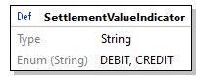
location | D:\Users\BKU\ClemensGantert\OneDrive - Deutsche Bahn\Anlagen\UIC\Standards\918-4\IRS 90918-4 v 3.0\90918-4 technical specs v3.0\90918-4_json_Schema_3_0_0\Untitled5.json
type | String
enumerations
  Type | Value
  string | DEBIT
  string | CREDIT
used by | AccountedAmount /  settlementValueIndicator
source code | "SettlementValueIndicator": {  "type": "string",  "enum": [  "DEBIT",  "CREDIT"  ]  }

Schema definition
TransactionStandarddiagram | 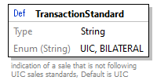
location | D:\Users\BKU\ClemensGantert\OneDrive - Deutsche Bahn\Anlagen\UIC\Standards\918-4\IRS 90918-4 v 3.0\90918-4 technical specs v3.0\90918-4_json_Schema_3_0_0\Untitled5.json
schema details
  Description | indication of a sale that is not following UIC sales standards, Default is UIC
  Default | "UIC"
type | String
enumerations
  Type | Value
  string | UIC
  string | BILATERAL
used by | AccountingRecord /  transactionStandard
source code | "TransactionStandard": {  "description": "indication of a sale that is not following UIC sales standards, Default is UIC",  "type": "string",  "enum": [  "UIC",  "BILATERAL"  ],  "default": "UIC"  }

Schema definition
TransactionTypediagram | 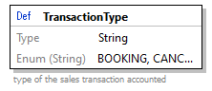
location | D:\Users\BKU\ClemensGantert\OneDrive - Deutsche Bahn\Anlagen\UIC\Standards\918-4\IRS 90918-4 v 3.0\90918-4 technical specs v3.0\90918-4_json_Schema_3_0_0\Untitled5.json
schema details
  Description | type of the sales transaction accounted
type | String
enumerations
  Type | Value
  string | BOOKING
  string | CANCELLATION
  string | EXCHANGE_CANCELLATION
  string | EXCHANGE_BOOKING
  string | COMPENSATION
  string | MANUAL_REFUND
  string | PREBOOKING_TIME_EXTENSION
used by | Transaction /  type
source code | "TransactionType": {  "description": "type of the sales transaction accounted",  "type": "string",  "enum": [  "BOOKING",  "CANCELLATION",  "EXCHANGE_CANCELLATION",  "EXCHANGE_BOOKING",  "COMPENSATION",  "MANUAL_REFUND",  "PREBOOKING_TIME_EXTENSION"  ]  }

JSON Schema documentation generated by XMLSpy JSON Schema Editor http://www.altova.com/xmlspy/json-schema-editor.html

